|  |
| --- |
| IN COLLABORATION WITH |
| **Magic Strikes** |
| **A Unity 3D Maze Game** |
| Version #1.0  All work Copyright © 2016  by  Bluesky Studios  &  Wimowomi Innovations.  All rights reserved. |
| **Angela Liu & Sara Womiloju** |
|  |

****

|  |
| --- |
| November 14, 2016 |

Table of Contents

[Version History 3](#_Toc466850184)

[Game Description 4](#_Toc466850185)

[**I.** **Game Overview** 4](#_Toc466850186)

[***II.*** **Camera** 4](#_Toc466850187)

[**III.** **Controls** 4](#_Toc466850188)

[**IV.** **Interface Sketch** 4](#_Toc466850189)

[a. Initial Wireframe of game design 4](#_Toc466850190)

[**V.** **Characters** 5](#_Toc466850191)

[***VI.*** **Enemies** 5](#_Toc466850192)

[**VII.** **Items** 5](#_Toc466850193)

[**VIII.** **Art / Multimedia Index** 5](#_Toc466850194)

[References 6](#_Toc466850195)

# Version History

Github Link: <https://github.com/saradoubleu/3D_Game>

Version 1.0



# Game Description

1. **Game Overview**

This first person player game has you (the scientist) running through town collecting coins and potions while avoiding the evil mummy that chases you. There is also a magical Pandora’s box that acts as an obstacle in the players path.

1. **Camera**

*The camera for this game uses a first person perspective from the players point of view.*

1. **Controls**

To control and navigate the first person player, the WASD keys or mouse movement can be used for player movement. Additionally, the space bar can be pressed allowing for multiple jumps.

1. **Interface Sketch**
2. Initial Wireframe of game design

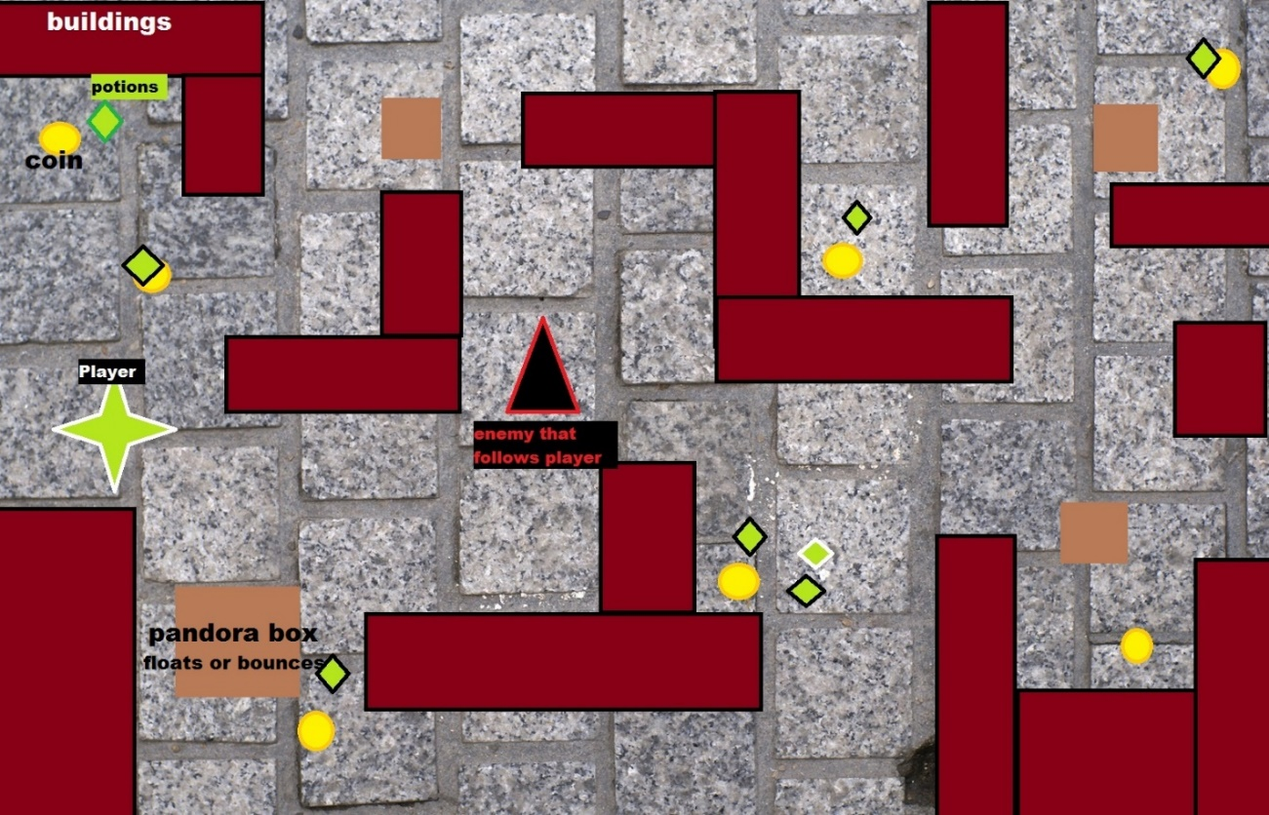

1. Final Game Design
2. **Characters**

The first person character can walk, jump or stand idle. Being a first person character, they can also rotate, or pivot to look up or down.

1. **Enemies**

The only enemy in the game is a mummy that follows the player as they navigate through the streets. Each collision decreases the players life span and eventually killing the player.

1. **Items**

*The player can pickup coins for points and grab potions for health. Both will increase the life span of the player.*

1. **Art / Multimedia Index**

|  |  |  |
| --- | --- | --- |
| **Name** | **Image** | **Details** |
| Chibi mummy | **C:\Users\sara womi\AppData\Local\Microsoft\Windows\INetCache\Content.Word\mummy.png** | Enemy |
| Bottles | **C:\Users\sara womi\AppData\Local\Microsoft\Windows\INetCache\Content.Word\Bottle_blue_diff.png** | Health |
| Coin | **C:\Users\sara womi\AppData\Local\Microsoft\Windows\INetCache\Content.Word\Coin_diffuse.png** | Points |
| BoxOfPandora | C:\Users\sara womi\AppData\Local\Microsoft\Windows\INetCache\Content.Word\BoxOfPandora_diffuse.png | obstacle |

# References

<http://www.textures.com/>

<http://www.turbosquid.com/3d-models/jfk-dollar-max-free/601669>

<https://www.assetstore.unity3d.com/>